Respiration in Mollusca
The phylum Mollusca has evolved a dazzling array of respiratory mechanisms to meet the metabolic needs of very different lifestyles. All molluscs are coelomate, triploblastic, bilaterally symmetrical animals with a soft, unsegmented body covered by a mantle. The mantle cavity houses the principal organs of respiration, excretion, and reproduction.
Primary respiratory function: Exchange of gases (O₂ and CO₂) between the environment and the circulatory system. Because of their varied environments such as marine, freshwater, terrestrial, molluscs employ several methods such as branchial, pulmonary, cutaneous, and even secondary modifications of the mantle cavity.
The Mantle Cavity
The mantle cavity is the fundamental site of respiration. It lies posteriorly in most molluscs but can shift anteriorly in others due to torsion as in gastropods.
Key roles of the mantle cavity:
1.Houses ctenidia (gills) or pulmonary sacs.
2.Provides space for circulatory blood sinuses near respiratory epithelia.
3.Maintains water or air flow via ciliary movement, muscular contraction, or hydrostatic pressure.
4.Facilitates excretion and reproduction alongside respiration—an elegant case of multifunctional anatomy.
3. Types of Respiratory Organs in Molluscs
A. Ctenidia (True Gills)
The ctenidium is the archetypal molluscan gill -feather-like, comb-shaped, and highly vascularized.
Structure:
1.Each ctenidium consists of a central axis or gill stem, bearing two rows of lamellae (bipectinate).
2.Each lamella is composed of numerous filaments, lined with ciliated columnar epithelium.
3.Blood channels run within each filament, creating a large surface area for gas diffusion.
Types of ctenidia:
1.Bipectinate– filaments arise on both sides of the axis. Example: Neopilina, Unio, Mytilus.
2.Monopectinate– filaments occur on one side only. Example: many advanced gastropods (Haliotis, Pila).
Blood flow: A counter-current mechanism ensures that blood with low oxygen meets water with high oxygen concentration enhancing diffusion efficiency.
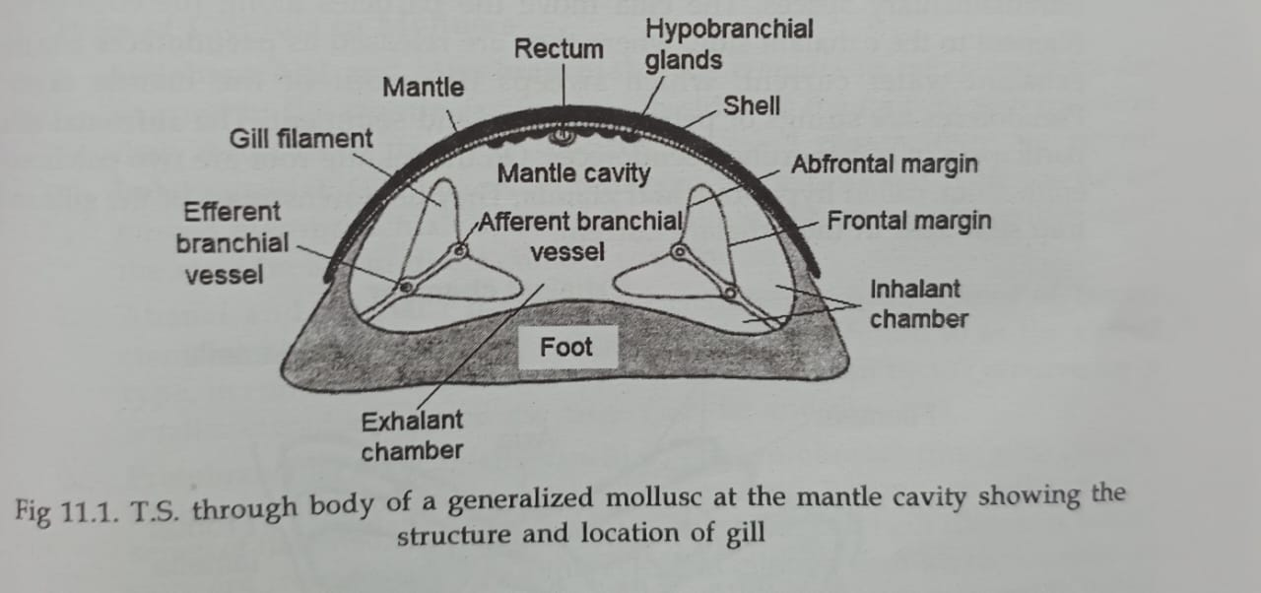

B. Secondary Gills in Cephalopods
Cephalopods such as squid, octopus, cuttlefish represent the high-performance end of molluscan respiration. Their metabolism demands rapid oxygen turnover.
Adaptations:
1.Two large ctenidia, one on each side of the mantle cavity.
2.Each ctenidium supplied by a branchial heart that pumps venous blood directly into the gill—unlike the single systemic heart of other molluscs.
3.The mantle musculature contracts rhythmically to draw water in and expel it through the funnel (siphon), providing both ventilation and jet propulsion.
Efficiency:
Oxygen extraction is 60–70%, comparable to fishes. The gills are folded into deep lamellae to increase surface area. The entire system is coordinated with the closed circulatory system unique to cephalopods, an evolutionary leap within Mollusca.

C. Pulmonary Cavities (Mantle Lungs) in Terrestrial Gastropods
Land snails (Helix aspersa, Achatina fulica) and amphibious species (Pila globosa) have transformed their mantle cavity into a pulmonary sac, a primitive lung.
Structure:
1.The mantle wall forms a highly vascularized epithelium.
2.Air enters and leaves through the pneumostome, a small opening on the right side of the body.
3.The lung wall’s blood sinuses are lined by thin endothelium and are in close contact with the air cavity.
4.Ventilation occurs by muscular contractions of the mantle floor ,expanding to draw in air, compressing to expel it.
In Pila globosa, The pulmonary cavity coexists with an aquatic gill (monopectinate type) for dual (amphibious) respiration. When underwater, the snail uses its gill; when on land, it draws air into the pulmonary sac via the pneumostome.

D. Cutaneous Respiration
Many small molluscs and those inhabiting moist environments use cutaneous (body surface) respiration as a supplementary mode.The epidermis must be:
1.Thin and moist,
2.Richly vascularized, and
3.Bathed in water or humid air.
Examples:
1.Limax (slug) relies heavily on skin respiration.
2.Chiton has marginal gills but also cutaneous exchange along its foot.
3.Larval molluscs (trochophore, veliger) breathe entirely through their body surface.

E. Pallial Respiration
In bivalves like Unio and Mytilus, the mantle surface itself participates in respiration in addition to the ctenidia. Fine blood sinuses just beneath the epithelium of the mantle allow direct gas diffusion, especially in low-oxygen environments.

4. Mechanism of Respiration
The pathway of gases in a typical aquatic mollusc (e.g., Unio):
1.Water Current: Cilia on the inner surfaces of the mantle and gills draw water through the inhalant siphon.
2.Gas Exchange: Water flows over the gill filaments.
  - O₂ diffuses from water into the blood within gill filaments.
  - CO₂ diffuses out from blood into water.
3.Exit:
Water exits through the exhalant siphon, carrying wastes and gametes when present.
5. Respiratory Pigments and Circulation
Haemocyanin
1.It is the Principal respiratory pigment in most molluscs.
2.Copper-based, giving the blood a bluish colour when oxygenated.
3.Dissolved in plasma (not inside cells).
4.Composed of multiple subunits, each binding one O₂ molecule via two Cu⁺ ions.
Reaction:
$$4Cu^{+}+O_{2}→2Cu^{2+}\text{–}O_{2}(oxyhaemocyanin)$$
Haemoglobin occurs rarely, found in some bivalves (Lucina), scaphopods, and certain gastropods (Planorbis).

*******************************************

