Botanical Garden Of India
- A botanical garden, also called a botanic garden, is a garden that contains a wide variety of plant species, usually labelled with their scientific names. A botanical garden is typically devoted to research, cultivation, preservation, and display of plants.
- As one of the world’s mega-biodiversity countries, India has a wide variety of plant species. India has one of the richest floras in the world, thanks to its sheer size, range of latitudes and altitudes, rainfall, and climatic and geographical conditions.
- There are about 200,000 living plants recorded in the accessions of these gardens.
- Acharya Jagadish Chandra Bose Botanic Garden in Kolkata is the first botanical garden established in India and also in South Asia.

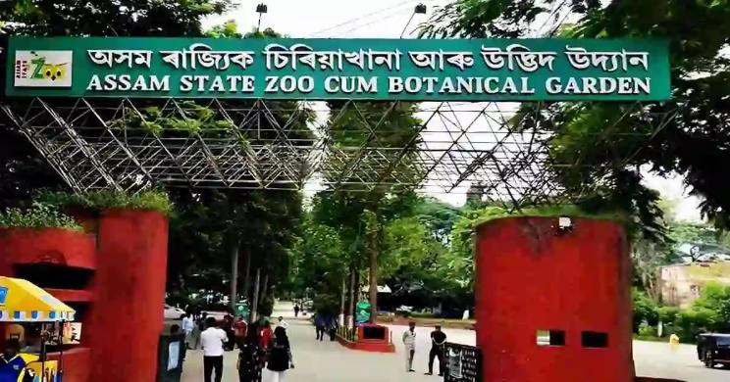
Assam State Zoo cum Botanical Garden, Assam

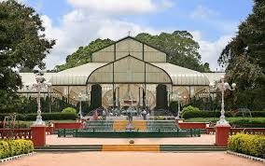
Lalbagh, Bangalore

History
- The first botanical garden of India was founded in 1787 by an army officer of the East India Company, named Colonel Robert Kyd. The primary purpose of establishing the garden was to identify new plant species, such as teak, which had great economic value and grow them on a commercial scale for trade.
- It was then named Royal Botanic Garden, Calcutta. Later, the name was changed to Calcutta Botanical Garden and then to Indian Botanic Garden. On 25th June 2009, the name was finally changed to Acharya Jagadish Chandra Bose Botanic Garden in honour of Acharya Jagadish Chandra Bose, a Bengali botanist-physicist and an early writer of science fiction.
- Over 12,000 specimens of rare plants are housed in the garden, which cover 109 hectares. Under the Ministry of Environment and Forests of India, the Botanical Survey of India (BSI) manages the centre.

Importance of Botanical Garden

As botanical gardens house a wide variety of plant species, it is an open, outdoor laboratory for a large number of students and botanists. Such a garden is important because:
- It is a place where a variety of endangered flora are conserved.
- It helps in taxonomic study and research.
- It provides the public with information about local and exotic species of plants.
- Rare species and genetic diversity are conserved and propagated in a botanical garden.

Botanical Gardens of India

There are about 122 botanical gardens recorded in India. Below is the list of the famous botanical gardens in India:
- Assam State Zoo-cum-Botanical Garden– Guwahati, Assam
- Botanical Garden Sarangpur – Chandigarh
- Sanjay Gandhi Jaivik Udyan – Patna, Bihar
- Botanical Garden Waghai – Gujarat
- Gujarat Technological University – Ahmedabad, Gujarat
- R. B. Botanical Garden and Amusement Park – Gujarat
- The Garça Branca Ayurvedic Botanical Garden – Loutolim, Goa
- National Cactus and Succulent Botanical Garden and Research Centre – Haryana
- Lalbagh – Bangalore, Karnataka
- Curzon Park – Mysore, Karnataka
- Mysore Zoo – Mysore, Karnataka
- Pilikula Arboretum, Pilikula Nisargadhama – Mangalore, Karnataka
- Regional Museum of Natural History Mysore – Mysore, Karnataka
- University of Mysore Botanic Garden – Mysore, Karnataka
- Prof. Nagaraj Botanical Garden – Kalaburgi, Karnataka
- Malabar Botanical Garden and Institute of Plant Sciences – Kozhikode, Kerala
- Malampuzha Garden – Palakkad, Kerala
- Jawaharlal Nehru Tropical Botanic Garden and Research Institute – Trivandrum, Kerala
- Vellayani Agricultural College – Trivandrum, Kerala
- Empress Garden – Pune, Maharashtra
- Odisha State Botanical Garden – Nandankanan, Bhubaneswar, Odisha
- Botanical Garden Guru Nanak Dev University – Amritsar, Punjab
- Botanical Garden Punjabi University – Patiala, Punjab
- Auroville Botanical Gardens – Auroville, Tamil Nadu
- Tamil Nadu Agricultural University – Coimbatore, Tamil Nadu
- The Institute of Forest Genetics and Tree Breeding – Coimbatore, Tamil Nadu
- Government Botanical Gardens, Ootacamund – Nilgiris, Tamil Nadu
- Semmozhi Poonga – Chennai, Tamil Nadu
- Botanical Garden, Hyderabad – Telangana
- NTR Garden – Hyderabad, Telangana
- Botanical Garden of India Republic – Noida, Uttar Pradesh.
- Jhansi Botanical Garden – Jhansi, Uttar Pradesh
- Saharanpur Botanical Garden – Uttar Pradesh
- Acharya Jagadish Chandra Bose Indian Botanic Garden – Shibpur, Kolkata, West Bengal
- Agri Horticultural Society of India – Alipore, Kolkata, West Bengal
- Garden of Medicinal Plants, North Bengal University – West Bengal
- Lloyd’s Botanical Garden – Darjeeling, West Bengal
- Narendra Narayan Park – Cooch Behar, West Bengal

